Workload Name

Well-Architected Reliability Assessment

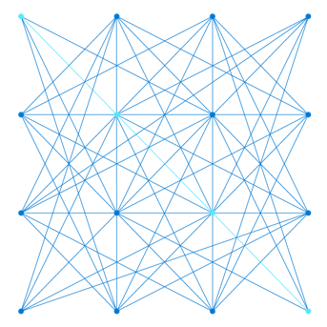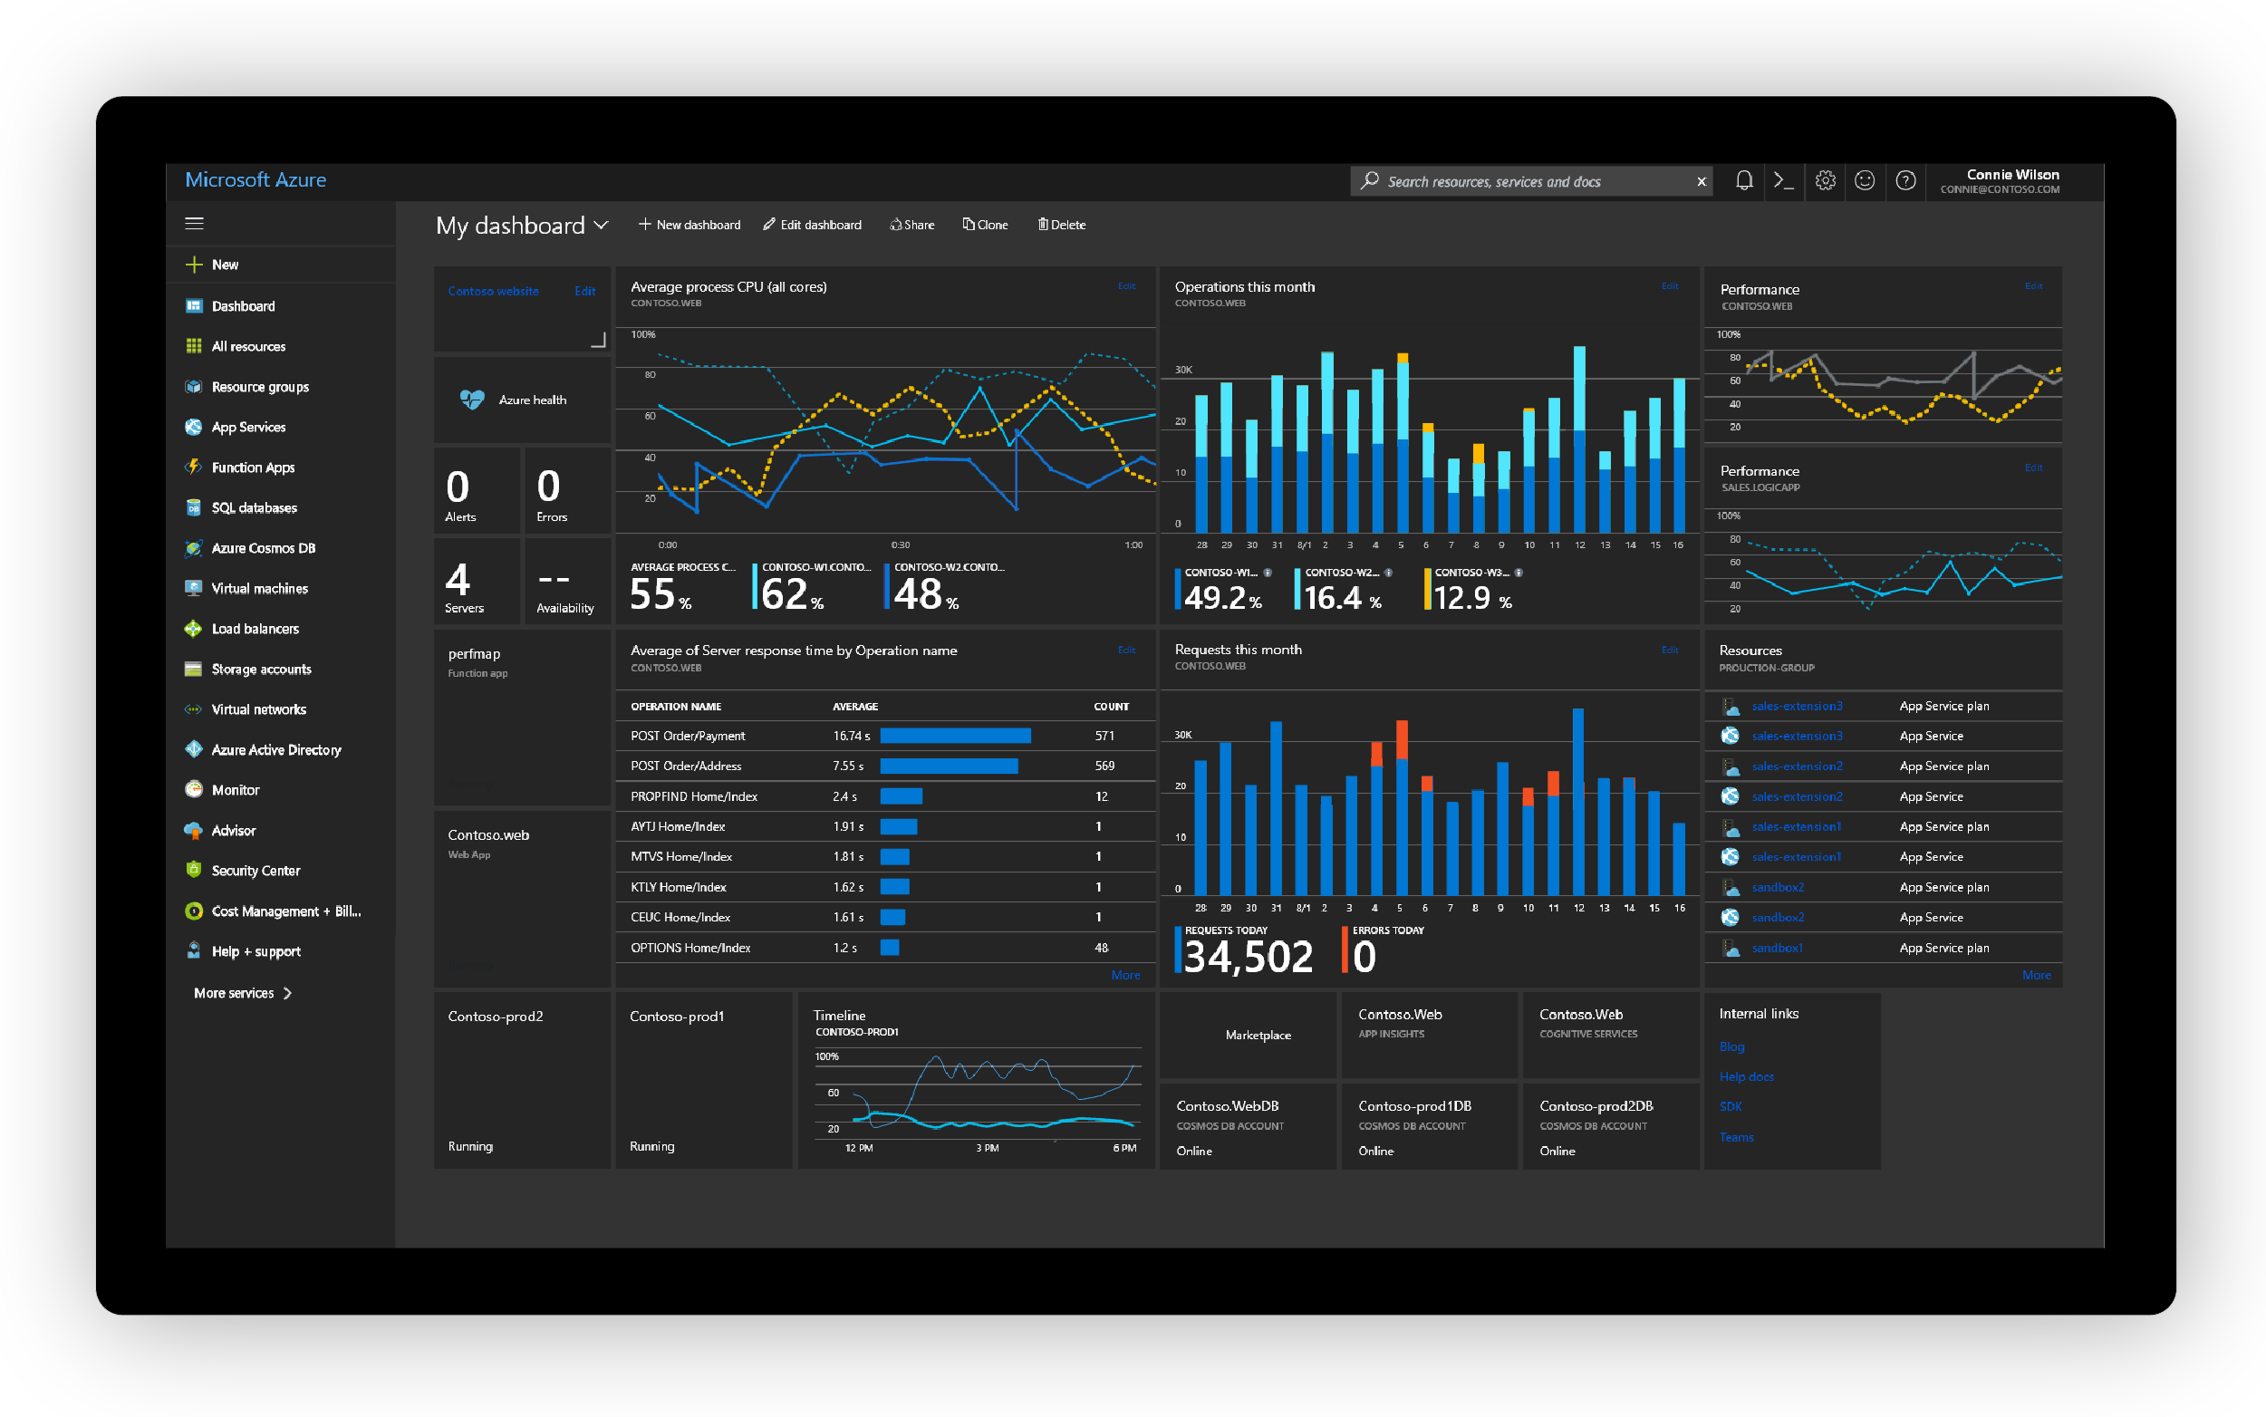

Customer Success



Prepared for

[Type Customer Name Here]

4/19/2024

Prepared by

**[Type Author Here]**

Cloud Solution Architect

email@microsoft.com

*Contributors*

[Type Contributors Here]

Table of Contents

1 Introduction 5

Workload information 5

2 Executive Summary 6

3.1 What is going well  6

3.2 Baseline Resiliency Metrics & Insights Dashboard 7

3.3 Health and Risk Dashboard 8

**Dashboard** 8

**Health Assessment Result (Azure Services)** – **Key High Impact issues** 8

**Risk Assessment Result (Well-Architected Framework)** – **Key High Impact issues** 8

**Health and Risk Charts** 9

3 Baseline Resiliency Metrics & Insights details 11

3.1 Zone and Region Resiliency 11

3.2 ExpressRoute Resiliency 12

3.3 Service Health Alerts for Resiliency 13

4 Health and Risk Recommendations 14

4.1 High Impact recommendations | Immediate fix needed 14

4.2 Medium Impact recommendations | Fix within 3-6 months 14

4.3 Low Impact recommendations | Needs to be reviewed 15

5 Design, Platform and Support recommendations 16

5.1 Architectural Recommendations 16

5.2 Recent Microsoft Outages (past 3 or 6 months)  16

5.3 Sev-A Support Requests (past 3-6 months) 17

5.4 Azure Service Retirement Notifications 18

6 Next Steps – Recommended Microsoft Services 19

6.1 Key Customer Responsibilities 19

6.2 Recommended Microsoft Services  19

7 References 21

**VBD Updates (REMOVE THIS PAGE BEFORE DELIVERING TO CUSTOMER)**

|  |  |
| --- | --- |
| Date | Changelog |
| 2024-02-29 | Added Baseline Metrics & Insights and reordered sections. |
|  |  |
|  |  |
|  |  |
|  |  |
|  | For detailed updates, check the release notes in the Delivery Guide. |

1. Introduction

This document is delivered to **[CUSTOMER NAME]** to detail the Reliability recommendations and optimizations identified during the Well-Architected Reliability Assessment.

Resiliency, Availability, Reliability, Recoverability are very important aspects of any architecture. They provide availability assurances against application and hardware failures and faults. Losing these assurances can negatively impact on the business operations and revenue, as well as the organization’s reputation in the marketplace.

This document details recommendations and optimizations for the Workload architecture design, Azure Services, and management practices based on the Microsoft Well-Architected Framework.

All recommendations and findings in this report are based on the discussions and research that took place between Microsoft and Workload Admins from <MONTH> to <MONTH> <YEAR>.

The Microsoft team was granted read access to the relevant subscriptions through the Azure Lighthouse service and provided several architectural documents and diagrams. The findings include observations, relevant examples of the observations, and a set of recommendations to improve the reliability of the workloads.

## Workload information

[Explain in high level the target workload, how it works, how it is used by customers/users, its key integrations and/or dependencies with other systems, add the architecture diagram, subscription IDs, summary of resource group names (in case the subscription is hosting more workloads), user flows, etc – Add pictures, diagrams, etc.]

1. Executive Summary

Microsoft has completed the resiliency review of the **[WORKLOAD NAME]** through a Discovery Workshop with the staff responsible for the workload and by running a suite of Azure tools to collect data from the target workload. The assessment provides findings and guidance based on analysis of your practices and Azure services being used against Microsoft proven best practices and recommendations provided by Azure documentation for each service, Well-Architected Framework documentation, and by the accredited Cloud Solution Architect(s) that delivered the engagement.

## 3.1 What is going well

* In place, active and tested Disaster Recovery and Backup solutions
* Internal load balancing within the application
* Current infrastructure sized to accommodate growth
* Azure resource monitoring connected to ITSM system to identify platform issues
* Redundant ExpressRoute paths to access the application exist
* Performance and fault testing process in place and operational

## 3.2 Baseline Resiliency Metrics & Insights Dashboard

This section shows the baseline metrics and insights critical for any workload. It highlights the adherence and adoption of Multi Zone, Multi Region, Multi ExpressRoute Peering Locations and configured Service Health Alerts.

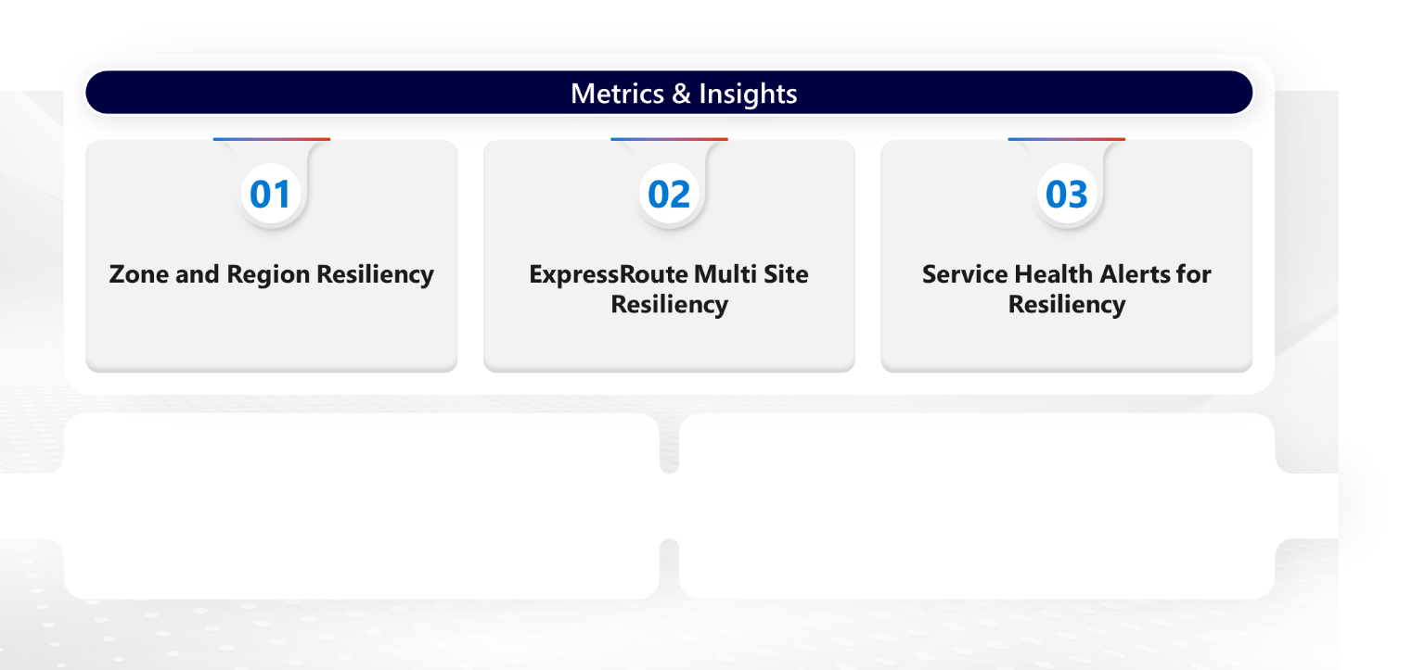

Service Health Alerts are configured for all Services automatically triggering actions

ExpressRoute does not have multi peering location resiliency

Workload is not fully protected against zone and region failure

## 3.3 Health and Risk Dashboard

This section contains recommendations to improve the reliability and resiliency of your Workload, Azure services and practices. The recommendations are organized into two categories:

* **Health items:** cover areas such as configuration items and the proper function of the major components that make up your Azure Workload, such as Azure Resource configuration settings, dependencies on other services, and so on.
* **Risk items**: cover areas such as availability and recovery requirements, testing, monitoring, deployment, and other items that if left unresolved increase the chances of problems in the environment. Usually the Well-Architected Framework best practices.

The impact is categorized as follows:

* **High** - Immediate fix needed
* **Medium** - Fix within 3-6 months
* **Low** - Needs to be reviewed

**Dashboard**

|  |  |  |  |  |  |  |  |  |  |  |  |  |  |  |  |  |  |  |  |  |  |  |  |  |  |  |  |  |
| --- | --- | --- | --- | --- | --- | --- | --- | --- | --- | --- | --- | --- | --- | --- | --- | --- | --- | --- | --- | --- | --- | --- | --- | --- | --- | --- | --- | --- |
| |  |  | | --- | --- | | **Total recommendations** | | | **38** |  | | |  |  |  |  |  |  | | --- | --- | --- | --- | --- | --- | | **Recommendations by impact** | | | | | | |  | |  | |  | | | **13** | High  impact | **22** | Medium impact | **3** | Low  impact | | |  |  | | --- | --- | | **Impacted resources** | | | **276** |  | |

**Azure Resources** – **Key High Impact issues**

* Virtual Machines not deployed across Availability Zones
* Production VMs using Standard HDD disks

**Well-Architected Framework** – **Key High Impact issues**

* The availability and recovery targets are not known or are not defined
* There is no BCDR strategy defined

**Recommendations Charts**

The charts below show recommendations for Azure Resource and Resiliency Categories:

1. Baseline Resiliency Metrics & Insights details

This section shows the details of baseline metrics and insights critical for any workload. It highlights the adherence and adoption of Multi Zone, Multi Region, Multi ExpressRoute Peering Locations and configured Service Health Alerts.

## 3.1 Zone and Region Resiliency

This section shows a summary of the zonal and regional redundancy of the workload and key components. The purpose of this section is to highlight the workload resilience to key outage scenarios and whether existing mitigation plans are validated on a regular basis.

|  |  |  |  |  |
| --- | --- | --- | --- | --- |
| **Workload Layer or Scenario**  **(Key Components Only)** | **Zone Failure Protection**  **(Yes/No/N.A.)** | **Region Failure Protection**  **(Yes/No/N.A.)** | **Zone Failure Testing**  **(Yes/No/N.A.)** | **Region Failure Testing**  **(Yes/No/N.A.)** |
| **Entire Workload** | No | No | No | No |
| AKS | Yes | Yes | Yes | Yes |
| App Services | No | No | Not Available | No |
| Azure SQL | Yes | No | Not Available | No |
| Virtual machines | No | No | Yes | No |
| Storage Accounts | Yes | Yes | Not Available | Yes |
| Virtual Network | Yes | Yes | Not Available | Yes |
| Azure Firewall | Yes | Yes | Not Available | Yes |

## 3.2 ExpressRoute Resiliency

This section shows a summary of the ExpressRoute Resiliency metrics and insight.

|  |  |  |  |  |  |
| --- | --- | --- | --- | --- | --- |
| Service | Recommendations | | | | |
| ExpressRoute Gateways | **Is your ExpressRoute Gateway connected to two or more Circuits from different Peering Locations for higher resiliency?** | **Are you using Zone-redundant gateway SKUs?** | **Do you have monitoring and alerting configured for your ExpressRoute Gateway(s) for all gateway metrics and logs** | **Do you have diagnostic logs with all necessary logs, and alerts configured for your ExpressRoute Gateway(s)?** | **Do you have customer-controlled gateway maintenance (Preview) configured?** |
| GatewayName | **No** | Yes | **No** | Yes | **No** |
|  |  |  |  |  |  |
| ExpressRoute Circuits | **What is your current ExpressRoute Peering location?** | **Are the two physical links of your ExpressRoute circuit connected to two distinct edge devices (routers/firewalls) in your network?** | **Are both connections of the ExpressRoute circuit configured in active-active mode?** | **Is (BFD) Bidirectional Forwarding Detection enabled and configured on customer or provider edge routing devices?** |  |
| CircuitName | Ashburn | Yes | Yes | **No** |  |
|  |  |  |  |  |  |
| ExpressRoute Direct | **Is the “Admin State” of both Links of your ExpressRoute Direct in Enabled state?** | **Is your ExpressRoute Direct over-subscribed?** |  |  |  |
| ExpressRouteDirect Port Name | Yes | **No** |  |  |  |
|  |  |  |  |  |  |

## 3.3 Service Health Alerts for Resiliency

This section shows a summary of the Service Health Alerts configured.

|  |  |  |  |  |  |  |  |  |
| --- | --- | --- | --- | --- | --- | --- | --- | --- |
| Subscriptions | Alerts | Service Health Alerts configured to monitor: | | | | | | |
| Subscription Name | **Alert Name** | **All Azure Services?** | **All Regions?** | **Event Type:**  **Service Issues?** | **Event Type:**  **Planned Maintenance?** | **Event Type:**  **Service Advisories?** | **Event Type:**  **Security Advisory?** | **Automatically triggering Actions to your teams?** |
| Sub Name 1 | Name | Yes | Yes | Yes | Yes | Yes | Yes | Yes |
|  |  |  |  |  |  |  |  |  |
|  |  |  |  |  |  |  |  |  |
|  |  |  |  |  |  |  |  |  |
|  |  |  |  |  |  |  |  |  |
|  |  |  |  |  |  |  |  |  |
|  |  |  |  |  |  |  |  |  |
|  |  |  |  |  |  |  |  |  |
|  |  |  |  |  |  |  |  |  |
|  |  |  |  |  |  |  |  |  |
|  |  |  |  |  |  |  |  |  |
|  |  |  |  |  |  |  |  |  |
|  |  |  |  |  |  |  |  |  |
|  |  |  |  |  |  |  |  |  |
|  |  |  |  |  |  |  |  |  |

1. Health and Risk Recommendations

This section outlines the recommendations organized by Azure services, Well-Architected Framework – Workload Lifecycle Stages, and Architecture Design. A number of risks have been identified through this assessment of solution. These risks are outlined below for review and remediation:

## 4.1 High Impact issues - Recommendations | Immediate fix needed

|  |  |  |  |
| --- | --- | --- | --- |
| # | Recommendation | Azure Service / WAF / Architecture Design | # of Impacted Resources |
| 1 | Use Zone-redundant gateway SKUs | ExpressRoute Gateway | 2 |
| 2 | Ensure the Availability Targets are well defined and communicated across teams working on the Workload. | WAF - Define | Workload |
| 3 | Production VMs should be using SSD disks | Virtual Machines | 40 |
| 4 | Connect Vnets directly with Vnet Peering when traffic inspection is not required | Architecture Design | 2 |
|  |  |  |  |
|  |  |  |  |
|  |  |  |  |
|  |  |  |  |
|  |  |  |  |
|  |  |  |  |
|  |  |  |  |
|  |  |  |  |
|  |  |  |  |

## 4.2 Medium Impact issues - Recommendations | Fix within 3-6 months

|  |  |  |  |
| --- | --- | --- | --- |
| # | Recommendation | Azure Service / WAF / Architecture Design | # of Impacted Resources |
| 1 | Use Zone-redundant gateway SKUs | ExpressRoute Gateway | 2 |
| 2 | Ensure the Availability Targets are well defined and communicated across teams working on the Workload. | WAF - Define | Workload |
| 3 | Production VMs should be using SSD disks | Virtual Machines | 40 |
| 4 | Connect Vnets directly with Vnet Peering when traffic inspection is not required | Architecture Design | 2 |
|  |  |  |  |
|  |  |  |  |
|  |  |  |  |
|  |  |  |  |
|  |  |  |  |
|  |  |  |  |
|  |  |  |  |
|  |  |  |  |
|  |  |  |  |

## 4.3 Low Impact issues - Recommendations | Needs to be reviewed

|  |  |  |  |
| --- | --- | --- | --- |
| # | Recommendation | Azure Service / WAF / Architecture Design | # of Impacted Resources |
| 1 | Use Zone-redundant gateway SKUs | ExpressRoute Gateway | 2 |
| 2 | Ensure the Availability Targets are well defined and communicated across teams working on the Workload. | WAF - Define | Workload |
| 3 | Production VMs should be using SSD disks | Virtual Machines | 40 |
| 4 | Connect Vnets directly with Vnet Peering when traffic inspection is not required | Architecture Design | 2 |
|  |  |  |  |
|  |  |  |  |
|  |  |  |  |
|  |  |  |  |
|  |  |  |  |
|  |  |  |  |
|  |  |  |  |
|  |  |  |  |
|  |  |  |  |

1. Design, Platform and Support recommendations

## 5.1 Architectural Recommendations

This section shows architectural recommendations that will help to mitigate some or all issues you faced in the past or will help to improve the overall resiliency and reliability of the workload.

[Add Diagrams if necessary]

|  |  |  |
| --- | --- | --- |
| **Component/Service** | **Observation** | **Recommendation/Change** |
|  |  |  |
|  |  |  |

## 5.2 Recent Microsoft Outages (past 3 months)

This section shows recent Microsoft outages (past 3 months) that may have impacted on the workload, as well as recommendations that will help to mitigate or minimize the impact of other possible similar outages. You can see this information via Azure Portal too.

|  |  |  |
| --- | --- | --- |
| **Tracking**  **ACM ID and**  **Outage Title** | **What Happened?** | **Recommendations** |
| VKBN-P80 - Intermittent connectivity issues - East US 2 | Between 04:06 and 09:00 UTC on 28 May 2023, customer workloads hosted in or connecting to resources in one Availability Zone (physical AZ02) in the East US 2 region may have seen inconsistent connectivity impacting these resources. Up to 1.6% of traffic may have been impacted, causing customers to observe connection failures, increased latency, or lower throughput. | Consider building logic into your service or application to retry requests or restart connections that fail or are slow, to reduce impact from this class of incident: <https://learn.microsoft.com/azure/architecture/patterns/retry>  This incident impacted a single datacenter in a single Availability Zone within the region. Consider architecting your services and applications to use multiple Availability Zones, to be more resilient to isolated zonal issues: <https://learn.microsoft.com/azure/reliability/availability-zones-overview>  More generally, consider evaluating the reliability of your applications using guidance from the Azure Well-Architected Framework and its interactive Well-Architected Review: <https://docs.microsoft.com/azure/architecture/framework/resiliency>  Finally, consider ensuring that the right people in your organization will be notified about any future service issues - by configuring Azure Service Health alerts. These can trigger emails, SMS, push notifications, webhooks, and more: <https://aka.ms/ash-alerts> |
|  |  |  |

## 5.3 Sev-A Support Requests (past 3 months)

This section shows recent (past 3 months) critical Support Requests that Workload Admins opened with Microsoft Remote Support, as well as recommendations that will help to avoid, mitigate, or minimize the impact of other possible similar future incidents. You can see this information via Azure Portal too.

|  |  |  |  |
| --- | --- | --- | --- |
| **Incident # and Title** | **Created Date** | **Cause and Resolution** | **Add your own recommendation. How they can avoid this happening again** |
| 2302180060000160 - Not Connecting to Pods | 2/18/2023 5:18 PM | **Cause:**  A config option in the nginx yaml file was forcing the probe to use HTTP protocol even when cx set probe parameter to TCP.  Backend was not responding to probes for HTTP on the set path and a 404 was being presented to the LB.  **Resolution:**  Customer found solution, in the YAML file, set a line "use app Protocol" to false and removed line "appProtocol". when the change was pushed to the LB, all probes are now using TCP as cx expected on the proper ports cx expected. | Make sure that all changes are validated in development environments before applying them to Production. |
|  |  |  |  |

## 5.4 Azure Service Retirement Notifications

This section shows Active Service Retirement Notifications that will likely affect the workload, as well as recommendations that will help to resolve the issue. You can see these notifications via Azure Portal too.

|  |  |  |
| --- | --- | --- |
| **Tracking**  **ACM ID and**  **Retirement Title** | **Subscriptions** | **Communication Update** |
| RV9Y-TP0 - Active : Final Notice: Windows Container virtual machine images that were retired on 30 April 2023 | 000-000-000-000 – Sub 1  000-000-000-000 – Sub 2  000-000-000-000 – Sub 3 | You're receiving this notice because you may still be using one or more Azure gallery images that we previously announced would be retired.  Previously, we communicated the support for the Mirantis Container Runtime (formerly Docker EE) on Windows Server will be transitioning to Mirantis Inc. This transition was extended until 30 April 2023 as a final extension.  We’ve identified through our telemetry that you may still be attempting to use one or more impacted virtual machine image(s). This is a final notification to inform you that you may experience service interruptions if you have not taken the required action.  Required action   1. Stop using the impacted container virtual machine images published by Microsoft (detailed in the following documentation) to help avoid further service disruptions. Please refer to the following for more information about the impacted images and options to transition from the retired virtual machine images that are retired. |
|  |  |  |

1. Next Steps – Recommended Microsoft Services

Implementing the technical recommendations identified during this assessment will make your workload more resilient, lessen outage risk, and reduce downtime. Our approach is centered around customers taking the lead in optimizing their environments as a joint effort with Microsoft. The Service Recommendations in Section 4.2 detail how Microsoft can partner with you through your Unified Support Contract to build a reliable, well-architected environment following Microsoft Best Practices based on the Microsoft Well-Architected Framework.

## 6.1 Key Customer Responsibilities

We advocate for a customer-empowered approach to rectify the issues identified in this report. Our recommendations and follow-up services will equip you with the knowledge and tools needed to reinforce your system's reliability. While Azure provides reliable uptime, Customers are accountable for the proper configuration, management, and security of the applications, data, and services deployed on Azure. That includes tasks like setting up firewalls, configuring access controls, encrypting data, managing user access, and ensuring application-level security. All these practices will make significant and practical contributions to the stability and reliability of your important solutions.

## 6.2 Recommended Microsoft Services

Our recommended remediation services are collaborative in nature. Microsoft Cloud Solution Architects will work with your team, offering tailored guidance to address the pinpointed concerns. As we work side by side, you'll gain firsthand experience in configuring and fine-tuning critical components of your system. This collaborative effort ensures that your solution is not only well-architected but also well-understood by your team, enhancing your organization's overall technological acumen.

Your CSAM and other account team members will work with you to determine how we can best assist you to move forward on strengthening the resiliency of your Workload.

**Replace the content below with the VBDs that will be recommended to this customer according to your findings.**

|  |  |  |
| --- | --- | --- |
| **Priority** | **Recommended Microsoft Service** | **Customer Value (Outcomes)** |
| High | EXAMPLE - BCDR With Azure Backup And Azure Site Recovery | Explain how this Microsoft Service will help the customer to mitigate the discovered issues |
| High | EXAMPLE - Migrating and Modernizing Virtual Machines to Azure | Explain how this Microsoft Service will help the customer to mitigate the discovered issues |
| Low | EXAMPLE - Monitoring Workloads | Explain how this Microsoft Service will help the customer to mitigate the discovered issues |
| Medium | EXAMPLE - Security: Azure Networking Design & Implementation | Explain how this Microsoft Service will help the customer to mitigate the discovered issues |

1. References

Designing Reliable Applications

* + [Building Resilient and Reliable Azure Applications](https://docs.microsoft.com/en-us/azure/architecture/framework/resiliency/overview)
  + [Error Handling for Resilient Cloud Applications](https://docs.microsoft.com/en-us/azure/architecture/framework/resiliency/app-design-error-handling)
  + [Cloud Application Resiliency Patterns](https://docs.microsoft.com/en-us/azure/architecture/patterns/category/resiliency)
  + [Cloud Application Availability Patterns](https://docs.microsoft.com/en-us/azure/architecture/patterns/category/availability)

Mission-Critical Workloads

* + [What is a mission-critical workload?](https://learn.microsoft.com/en-us/azure/well-architected/mission-critical/mission-critical-overview#what-is-a-mission-critical-workload)

Operating Reliable Applications

* + [Site Reliability Engineering Resources](https://docs.microsoft.com/en-us/azure/site-reliability-engineering/)

Well Architected Framework Learning Path

* + <https://docs.microsoft.com/en-us/learn/paths/azure-well-architected-framework/>